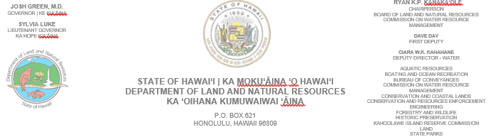
July 31, 2026

TO: Prospective Bidders

FROM: Reynold Lee, Land Agent
Department of Land and Natural Resources, Land Division

SUBJECT: Clean and clear the Lower Kapahi Reservoir irrigation drainage gate outlet area and both entry and exit of the culvert area as requested by the DLNR-Dam Safety Engineer to prevent flooding and blockage of the flow of water within the reservoir that may jeopardize the safety of the dam. Cut and remove all debris, shrubbery and vegetation within a 25 foot radius of the existing gate outlet, entry and exit of culvert area on State lands at Kapaa, Kawaihau, Kauai, Tax Map Key: (4) 4-6-006: 007.

Maintain drainage gate, entry and exit of culvert area by cutting and removing shrubbery within a 25 foot radius every three (3) months for one (1) year starting from completion of initial cleaning and clearing date.

Please submit a quotation for the cleaning and removal of debris, shrubbery and vegetation at the Lower Kapahi Reservoir for the outlet gate, entry and exit of culvert area and for the maintenance of the outlet gate, entry and exit of culvert area by cutting and removing shrubbery within a 25 foot radius every three (3) months for the period of one (1) year starting after completion of initial cleaning upon a State parcel, vicinity of Lower Kapahi Reservoir and Kahuna Road (Outlet is at the lower end of the reservoir and goes under Kahuna Road) in Kapaa, Kawaihau, Kauai, Tax Map Key: (4) 4-6-006: 007.

Must attend on site meeting at Lower Kapahi Reservoir to confirm location. Tuesday, August 4 @ 10:30 a.m.

Please submit your fee quote online by 2:00pm on August 7, 2026, to qualify as a prospective bidder for this project.

Vendor compliance will be conducted via Hawaii Compliance Express (HCE). Compliance is required from the successful bidder prior to awarding project and commencement of work activities. It is the responsibility of the vendor to ensure they are registered with HCE and their information is updated and accurate.

SCOPE OF WORK:

- Clean and clear the Lower Kapahi Reservoir irrigation drainage gate outlet, entry and exit of culvert area as requested by the DLNR-Dam Safety Engineer to prevent flooding and blockage of the flow of water within the reservoir that may jeopardize the safety of the dam. Cut and remove all debris, shrubbery and vegetation within a 25 foot radius of the existing gate outlet, entry and exit of culvert area on State lands at Kapaa, Kawaihau, Kauai, Tax Map Key: (4) 4-6-006: 007.

- Maintain the drainage gate, entry and exit of culvert area by cutting and removing shrubbery within a 25 foot radius every three (3) months for the period of one (1) year starting from after completion of initial cleaning and clearing date.

Should you have any questions regarding the above, please give me a call at 274-3491, fax at 241-3535, or email at reynold.km.lee@hawaii.gov. Mahalo!

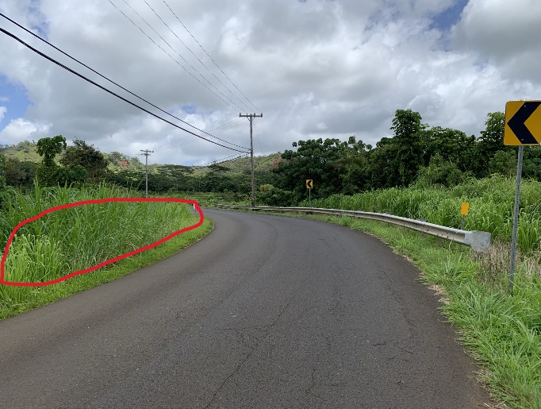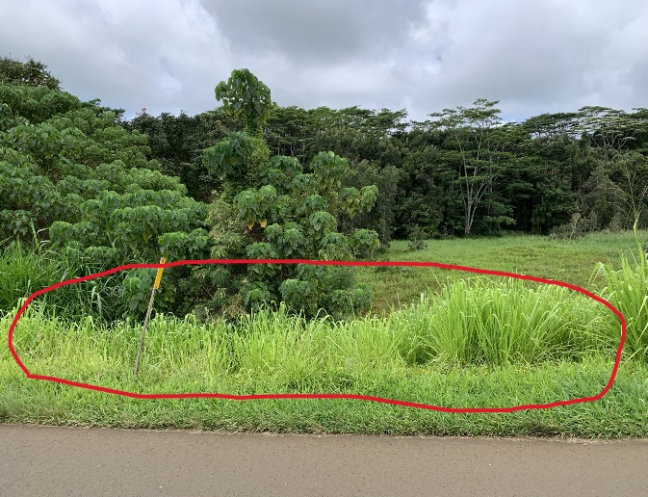

This is Kahuna Road, lowest end of the reservoir: The red circles are the estimated area to be cleared and maintained down the slope to the drainage gate outlet. Culvert entry is at bottom of hill by drainage gate. Culvert goes under Kahuna Road and culvert exit is on opposite side of road. Exact area to be pointed out at site meeting.

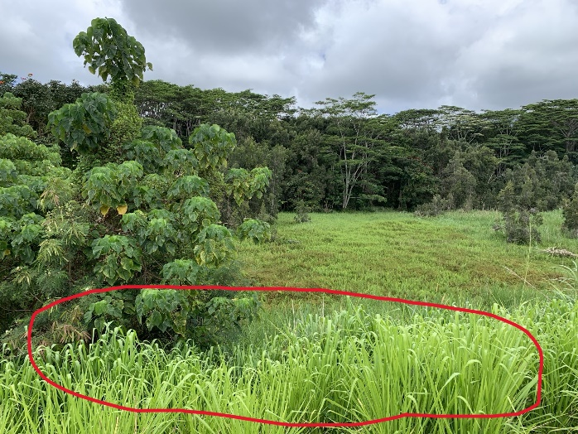

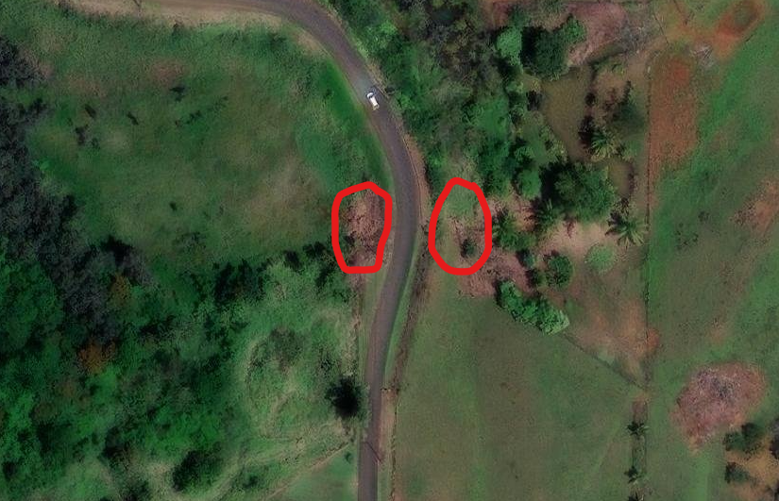
Approximate Areas to be cleaned and maintained.

